**Homework 3**

Problem 1.

Create a Web Page like the following.

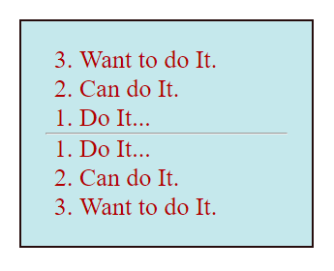

Create two files: “**reversed-list.html**”and“**reversed-list.css**”

### Constraints

* <div>with **id=wrapper** as a **container**
  + Background color: **#c5e8ec**;
  + Text color: **#b30000**;
  + Width container: 300px;
  + Border: 1px solid **#260d0d**;

Problem 2.

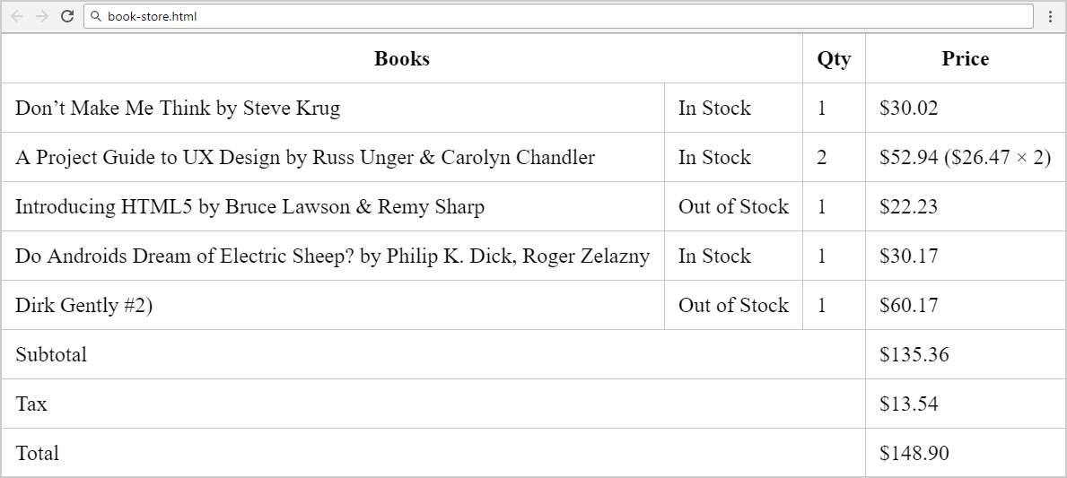Create a Web Page like the following.

Create two files: "**book-store.html**" and "**book-store.css**".

### Constraints

* **Merge columns** in several table rows by using “colspan”.
* Table border color: #c6c7cc.
* Apply **padding** for all **table cells**.
* **Collapse** table borders to remove the empty space between the cells: <https://css-tricks.com/almanac/properties/b/border-collapse/>.

Use:

* First reset the CSS styles.
* Use **&#8217;** for the **apostrophe**.
* Search Internet for **currency symbol HTML entiities** and other special symbols like **&**.

Problem 3.

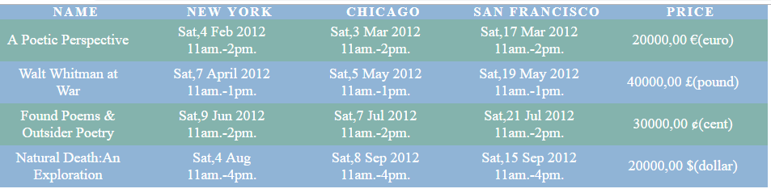Create a Web Page like the following.

Create two files: "**table.html**" and "**table.css**".

Use **semantic HTML** to create the page.